(Approx. 649 words)

OneDrive Files on Demand
By Nancy DeMarte, 2nd Vice President,
The Sarasota Technology Users Group, FL
March 2018 issue, Sarasota Monitor
www.thestug.org / ndemarte (at) verizon.net

The 2017 Creators update (1709) to Windows 10 included several changes. One of my favorites is “Files on Demand,” a new process to make files stored on OneDrive, the Microsoft cloud, available on your PC and other devices.

Anyone with a Windows 10 computer and a Microsoft account automatically has 5GB of free storage on OneDrive. If more space is needed, $1.99 a month will provide 50GB of storage. Office 365 subscribers have 1TB (1000 GBs) of OneDrive storage. If you have files stored on OneDrive, you might want to consider Files-on-Demand to manage them.

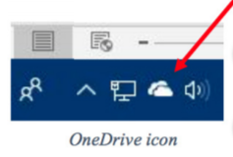
To set up Files-on-Demand, you must enable it in OneDrive. First, locate the OneDrive icon on your computer. It may be listed in the File Explorer left column, or it may be an icon in the notification area of the taskbar. If it isn’t visible in that area, click the upside-down V and look for it in the group of hidden icons that opens. The OneDrive icon resembles two white or blue clouds overlapping. If you still can’t find it, try using the Cortana search box or get it from the Microsoft store or Apple store.
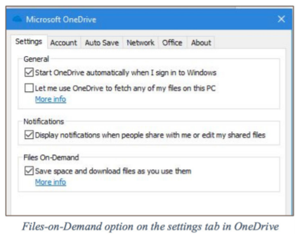
Right-click the OneDrive icon and click the Settings tab. Under Files-on-Demand, click next to “Save space and download files as you use them.” and click OK. The feature in now enabled. If you want to use Files-on-Demand in OneDrive on other devices besides your computer, you need to enable it on each device.

The goal of Files-on-Demand is to save space on your computer or device by storing files on the Internet but making them easily available and up to date on your computer and other devices.

- If you double-click a file in OneDrive, it downloads to your computer or device while remaining stored on OneDrive.
- If you right-click one or more OneDrive files and select “Always keep on this device,” files will be available on both your device and OneDrive but will use hard drive space.
- If you want to save space on your computer, right click a file or folder in OneDrive and click “Free up space.” This makes new files created on other devices sync to your computer. If you do not click this command, these new files will appear as online-only.

To help you remember what the status is of files and folders saved in OneDrive, a new status column has been added that contains an icon next to each file. The screen shot below shows how they look and what the icons mean.

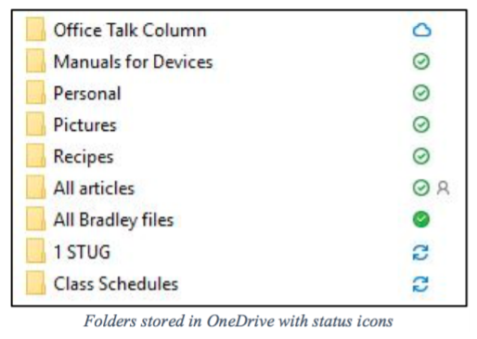
The folder next to the white cloud with a blue outline is stored only on OneDrive. The folders with a checkmark in a white circle outlined in green will download to the computer when opened. The small people icon means that folder is shared.

The folder with the solid green circle and checkmark has been marked “Always keep on this device.” It will use hard drive space.

Although stored in OneDrive, the two folders with blue circular arrows are synced between OneDrive and one or more computers and devices.

Tips:
- If you delete a file from OneDrive using File Explorer, it will also be deleted from your
- device.
- If you want to disable Files-on-Demand, go to One Drive Settings tab and remove the
- checkmark next to “Save space and download files as you use them.” When the feature is turned off, all your files which are synced to OneDrive will download to your computer and will no longer sync.
- For more information about Files-on-Demand, here is a useful website. Copy and paste it into the address bar on your browser: http://bit.ly/2p8KJAc

It takes a little practice to get used to this new system, but its options make it an improvement over the old one.

